Course Title: Web Development

Course Code: IMD1005

Semester: Winter 2026

Name: Hao Ding

ID: 101217067

Client Introduction
Alex Morgan is one of the IMD students and is preparing his own portfolio website. He needs a clear and unique website to introduce himself and show the list of his projects.
- Age:24
- Website type: Personal Portfolio
- Target Users: Human Resources officers from Networking company
- Requirement: Clear and Impressive web design, including self-introduction and contact information, and a list of different projects

The IMD student needs a way to show his portfolio and leave a memorable impression because he needs to find a job quickly in the competitive design industry.

Prototype Design
So now I’m going to ask for more details about the website.

Empathize
According to the interview, I learned more information about the client. He is about to graduate next year, so it’s time to think about his portfolio now. He’s already had some personal introduction texts, and showed me some of his projects on various platforms, like itch.io, YouTube, etc. Though he knows it’s difficult to get a perfect well-designed website for now, he decides to share and show his projects first.

Define
The IMD student needs a way to show his portfolio and leave a memorable impression because he needs to find a job quickly in the competitive design industry.
So now the requirement is clear. The IMD student needs a way to show his portfolio and leave a memorable impression because he needs to find a job quickly in the competitive design industry.
The first and most important requirement is clear. The information should be short and straightforward, easy to read. Considering the time to catch attention is limited, it’s better to use more icons and graphics and limit the texts, unless for necessary information, like introduction.
There is no specific requirement for the color, but the color must match with a specific theme color, avoid uncomfortable match up.
The website is designed to express personal design, so another requirement is unique. It’s required to catch the user’s attention at the first second. Due to my lack of experience in colors, I will use a relatively dull color first. As for the layout, it would be better to show some uncommon structure, but for the prototype I’ll consider readability first.

Ideate & Prototype

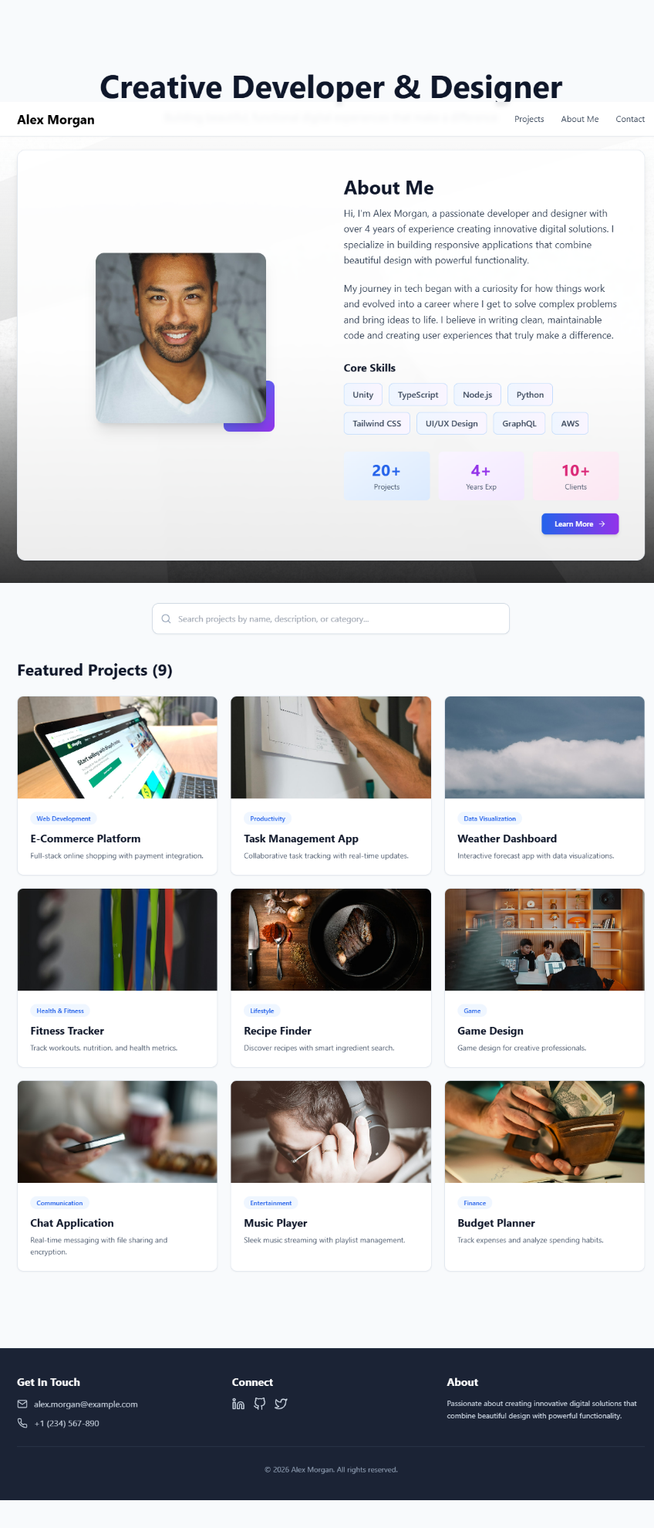

Here is the link on github:
https://github.com/HDisHERE/BITIMD1005-W26-Assignment01.git

This step is simple. I used Figma Make to help me design a rough prototype of the website step by step, then made some changes. There are 11 versions in total, and here are some key prompts.
-I need to build a website as a multimedia designer’s portfolio. Just give me an example, including a title, a nav bar, a search bar, and the library of different projects. Each project on the site has an icon on the top, along with a short name and description. Just like menu.
-Excellent, now I need to make some changes to the icon. First, the icon is too small to show the actual project. I need to enlarge each icon and shorten the description
-Actually, it's my fault. What I need is something larger than the square icon. Could you put some actual Picture on the top?

Here I made some changes to the icon. At first all the icons are tiny and squeezed into the top right corner of each project introduction. Besides, the icon looks like the mobile app rather than an actual project, so I changed it into some real picture.

Great! Now the background is kind of lame. I wonder if you can put some transparent picture on the background? It would be better if it has a gradual filter on top, which is white on the top and black at the bottom

Here I decided the add some gradient color to the background, to balance the color change from top navbar to the foot. Besides it’s also part of the visual guidance leading to the bottom.

OK, the web is perfect now. Let's add some more details. First, I need an example of contact information and copyright information at the bottom
Then I need to add more pages. On the nav bar, add a section called "About me". and create a self-introduction page.
Looks great. For more details, add a tiny button at the right bottom corner of introduction part, and the button refer to a link of a more detailed introduction page

Here I decided to put the self-introduction on top of the library, to show some key ability first. Then put the library of projects below with a search bar. All in all, it’s important to introduce the designer to the users and leave an impression of skills first.

There are some problems when exporting it. The main structure of Figma Make is .tsx, which is kind of complex for me. Even if I exported everything as .html & .css later, the code structure is still hard to read.
Besides, here are some problems with the theme color. I ask Figma Make to change it into orange and make some unique patterns for decoration, but it seems that all the pictures are still image rather than .css designs, thus I failed to make changes to that. And when I open the file in VS Code, all the color on navbar is missing. Still, the basic structure is complete.

According to the client, this is just a prototype for layout reference. Pictures on the web are irrelevant to personal information.

Feedback & Improvement
Here is some key feedback from the user test interview. Most interviewees are my friends and relatives.

What’s your first impression of the web site?
Jelena (IMD student): The web looks well designed, but it seems that the navbar is kind of empty. Besides the color is too official for a portfolio website, matbe try some more vivid color?
Yan(AS student):It looks cool, but why is there such a library on top? I thought it’s a game collection website at first.

Do you find anything hard to read or understand?
Max(AS student): The page is easy to read, I’m just curious about some terminologies on this page.
Jelena(IMD student): Instead I think it’s too simple. Maybe add some more motion feedback to the buttons?

Do you find it difficult to go through this website?
Neo(BIT):It looks good, but I want to learn more about different projects. I’m just curious on the pictures of project.
Ray(BIT):The self-introduction could be too long. Maybe you can change the layout a little.

According to the feedback above, I tried to make some changes to the theme color, but as I mentioned in VS Code the color didn’t change. Besides, to avoid the distractions from different projects, I decided to introduce the client to the users first, so I changed the position of self-introduction.

References
Here are links of reference images and tools.
AI Tool: https://www.figma.com/make/

Pictures:
https://images.unsplash.com/photo-1595411425732-e69c1abe2763?crop=entropy&cs=tinysrgb&fit=max&fm=jpg&ixid=M3w3Nzg4Nzd8MHwxfHNlYXJjaHwxfHxhYnN0cmFjdCUyMGdlb21ldHJpYyUyMHBhdHRlcm58ZW58MXx8fHwxNzY5MDg1Nzk1fDA&ixlib=rb-4.1.0&q=80&w=1080&utm_source=figma&utm_medium=referral
https://images.unsplash.com/photo-1507003211169-0a1dd7228f2d?crop=entropy&cs=tinysrgb&fit=max&fm=jpg&ixid=M3w3Nzg4Nzd8MHwxfHNlYXJjaHwxfHxwcm9mZXNzaW9uYWwlMjBwb3J0cmFpdCUyMHBlcnNvbnxlbnwxfHx8fDE3MzY1MTU1MzV8MA&ixlib=rb-4.1.0&q=80&w=1080&utm_source=figma&utm_medium=referral
http://www.w3.org/2000/svg
https://linkedin.com
https://github.com
https://twitter.com
https://images.unsplash.com/photo-1658297063569-162817482fb6?crop=entropy&cs=tinysrgb&fit=max&fm=jpg&ixid=M3w3Nzg4Nzd8MHwxfHNlYXJjaHwxfHxvbmxpbmUlMjBzaG9wcGluZyUyMGVjb21tZXJjZXxlbnwxfHx8fDE3NjkwOTk4NjV8MA&ixlib=rb-4.1.0&q=80&w=1080
https://images.unsplash.com/photo-1699570044128-b61ef113b72e?crop=entropy&cs=tinysrgb&fit=max&fm=jpg&ixid=M3w3Nzg4Nzd8MHwxfHNlYXJjaHwxfHx0YXNrJTIwbWFuYWdlbWVudCUyMHByb2R1Y3Rpdml0eXxlbnwxfHx8fDE3NjkxMjk4MTd8MA&ixlib=rb-4.1.0&q=80&w=1080
https://images.unsplash.com/photo-1766203695519-f5b060b72d54?crop=entropy&cs=tinysrgb&fit=max&fm=jpg&ixid=M3w3Nzg4Nzd8MHwxfHNlYXJjaHwxfHx3ZWF0aGVyJTIwZm9yZWNhc3QlMjBza3l8ZW58MXx8fHwxNzY5MDQ0ODE3fDA&ixlib=rb-4.1.0&q=80&w=1080
https://images.unsplash.com/photo-1584827386916-b5351d3ba34b?crop=entropy&cs=tinysrgb&fit=max&fm=jpg&ixid=M3w3Nzg4Nzd8MHwxfHNlYXJjaHwxfHxmaXRuZXNzJTIwd29ya291dCUyMGd5bXxlbnwxfHx8fDE3NjkwMDM3NDV8MA&ixlib=rb-4.1.0&q=80&w=1080
https://images.unsplash.com/photo-1635661988046-306631057df3?crop=entropy&cs=tinysrgb&fit=max&fm=jpg&ixid=M3w3Nzg4Nzd8MHwxfHNlYXJjaHwxfHxmb29kJTIwY29va2luZyUyMHJlY2lwZXN8ZW58MXx8fHwxNzY5MTI5ODE3fDA&ixlib=rb-4.1.0&q=80&w=1080
https://images.unsplash.com/photo-1742440710226-450e3b85c100?crop=entropy&cs=tinysrgb&fit=max&fm=jpg&ixid=M3w3Nzg4Nzd8MHwxfHNlYXJjaHwxfHxjcmVhdGl2ZSUyMHdvcmtzcGFjZSUyMGRlc2lnbnxlbnwxfHx8fDE3NjkxMjQ0NjR8MA&ixlib=rb-4.1.0&q=80&w=1080
https://images.unsplash.com/photo-1516210938721-0703012a297a?crop=entropy&cs=tinysrgb&fit=max&fm=jpg&ixid=M3w3Nzg4Nzd8MHwxfHNlYXJjaHwxfHxtZXNzYWdpbmclMjBjb21tdW5pY2F0aW9uJTIwcGhvbmV8ZW58MXx8fHwxNzY5MTI5ODE4fDA&ixlib=rb-4.1.0&q=80&w=1080'
https://images.unsplash.com/photo-1572119244337-bcb4aae995af?crop=entropy&cs=tinysrgb&fit=max&fm=jpg&ixid=M3w3Nzg4Nzd8MHwxfHNlYXJjaHwxfHxtdXNpYyUyMGhlYWRwaG9uZXMlMjBhdWRpb3xlbnwxfHx8fDE3NjkxMjk4MTh8MA&ixlib=rb-4.1.0&q=80&w=1080
https://images.unsplash.com/photo-1764407395696-495d7fb7fc71?crop=entropy&cs=tinysrgb&fit=max&fm=jpg&ixid=M3w3Nzg4Nzd8MHwxfHNlYXJjaHwxfHxmaW5hbmNlJTIwbW9uZXklMjBidWRnZXR8ZW58MXx8fHwxNzY5MTI5ODE5fDA&ixlib=rb-4.1.0&q=80&w=1080

